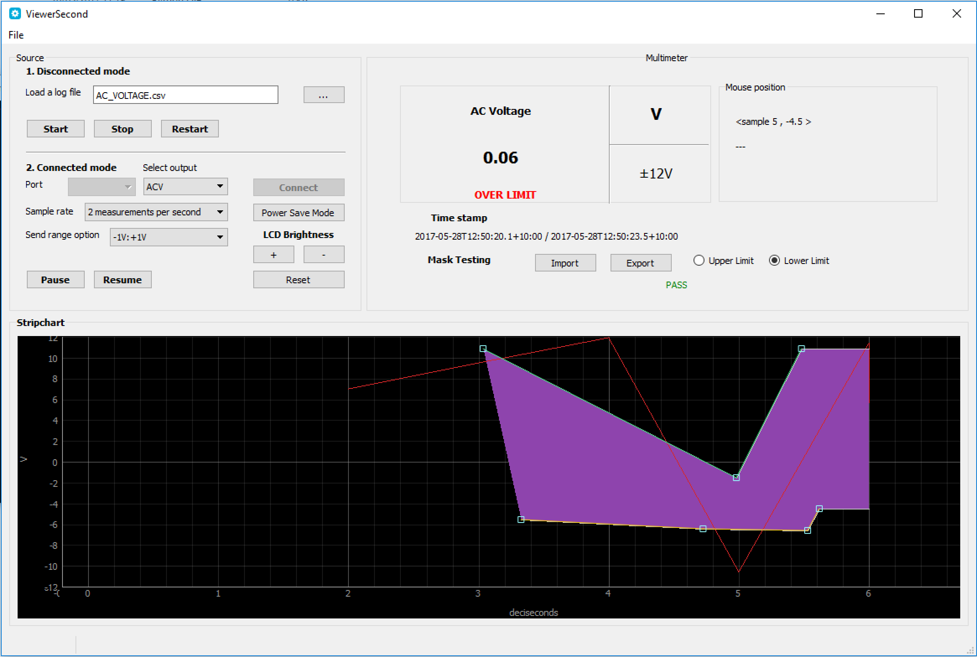

To be able to run this code on Windows machines, you will need to do the following steps:

1. Install Python 2.7
2. Install Python(x,y).
   1. Install PyQt4
   2. Install Pyserial
   3. Install Matplotlib
   4. Install PyQtGraph
3. Click on viewersecond.py
4. To generate a portable executable file of this code, follow the next steps.
   1. Go to powershell
   2. Type pip install pyinstaller
   3. cd to the source code folder
   4. type:
      1. pyinstaller --onedir --onefile --name=ENGG4810T33 --windowed .\viewerSecond.py
      2. Wait a few minutes
      3. Click on exe file
5. To generate software installer, continue with these steps:
   1. Open *Inno Setup* and follow instructions